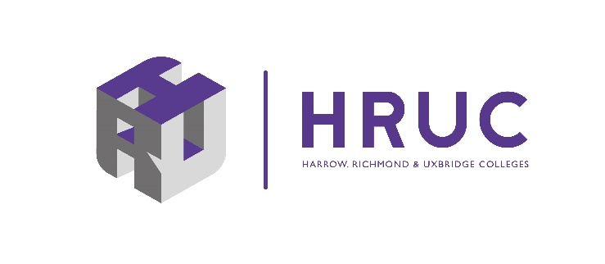

HRUC - Harrow, Richmond & Uxbridge Colleges. Better together, stronger together.
On Wednesday 4 January 2023 HCUC (Harrow College & Uxbridge College) merged with Richmond upon Thames College to form HRUC - Harrow, Richmond & Uxbridge Colleges.
The merger brings our three colleges together to form London's newest college group, providing even more opportunities for our students, helping them achieve more, progress further and become even more work ready.
Our merger builds on the outstanding areas and strengths that HCUC achieved in its previous Ofsted inspection, pre-merger with Richmond upon Thames College.
By merging we can do more for our students and continue to deliver a high-quality learner experience, ensuring that the benefits to them increase. Students will access high-quality teaching providing more opportunities to progress into further learning or onto getting the job they want.
We will further expand our Science, Technology, Engineering and Maths (STEM) provision through the West London Institute of Technology and a brand-new STEM building with state-of-the-art facilities based at Richmond upon Thames College.
Keith Smith, CEO said, “This merger brings an exciting future for learners and employers in the west London area, with new collaborative opportunities to deliver outstanding quality and support local businesses to get skills they need. We will invest in new STEM facilities, deliver exciting opportunities for young people to progress into higher education through A Levels and T Levels, and expand our West London Institute of Technology to deliver the best and most innovative technical education anywhere in the country.”

